IT24101669

Sasmitha W.A.M.

PS – Lab10

**Exercise**

1)

Null hypothesis (H₀): Customers choose the four snack types (A, B, C, D) with equal probability

Alternative hypothesis (H₁): Customers do not choose the four snack types with equal probability

2)

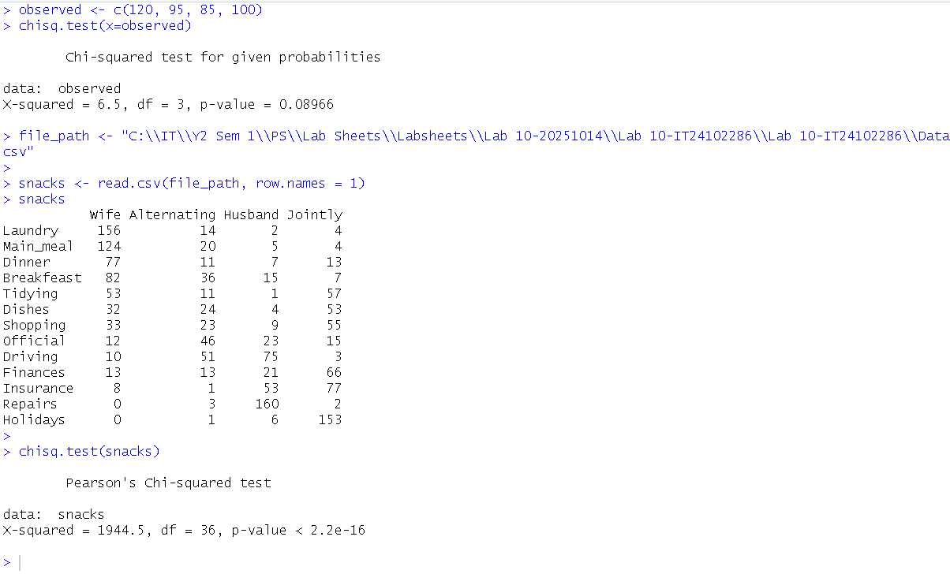

3)

Conclusion -

At a 5% significance level (α = 0.05), the p-value (0.08966) is greater than 0.05. Therefore, we fail to reject the null hypothesis. There is insufficient evidence to conclude that customers do not choose the snack types with equal probability. The data supports the vending machine owner's claim.